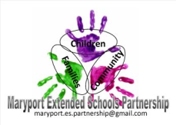
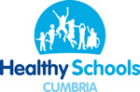
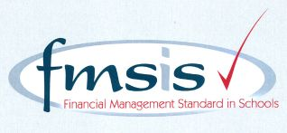
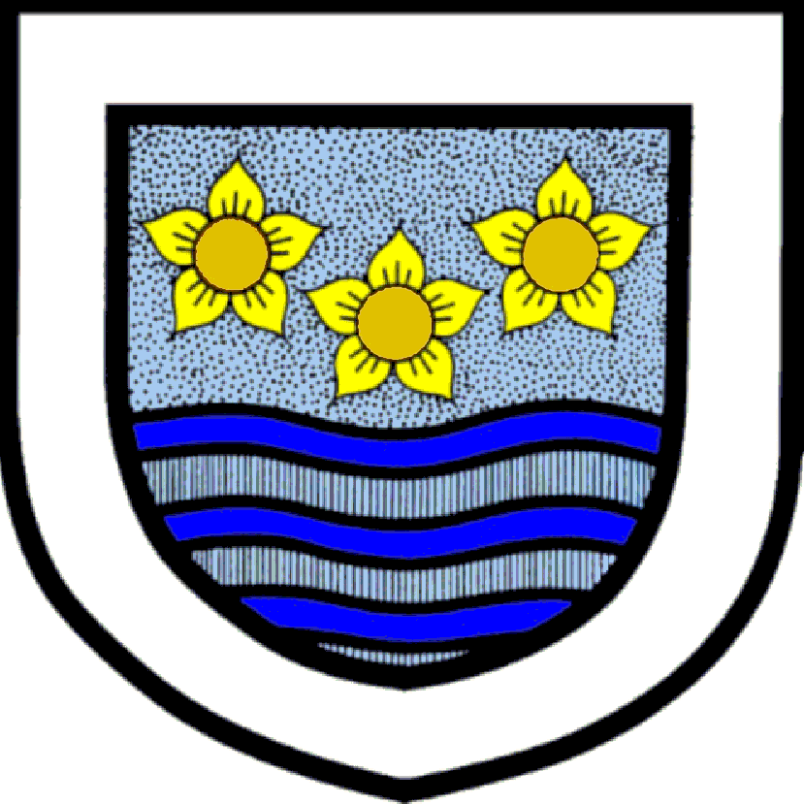
Big enough for opportunity
Small enough to care
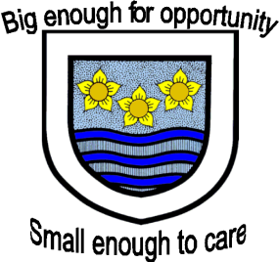

CROSSCANONBY ST JOHN'S CofE PRIMARY SCHOOL

Mrs A Pitcher Telephone: 01900 812326
Executive Headteacher Fax: 01900 816420
Garborough Close e-mail: head@crosscanonby.cumbria.sch.uk
Crosby www.crosscanonby.cumbria.sch.uk

MARYPORT

Cumbria CA15 6RX

Dear Parents/Guardians,

For your information we have outlined below some of the topics that will be covered this term in Year 5. We have already made a good start to our studies and we feel sure that you will make every effort to assist and encourage your child as this term progresses.

ENGLISH:
- Historical Fiction – ‘Anglo-Saxon Boy’
- Descriptive writing
- Information texts – job advertisements
- Writing diary entries
- Newspaper reports
- Writing stories
- Poetry

SPaG (Spelling, grammar and punctuation):
- Determiners
- Fronted adverbials
- Modal verbs of possibility
- Using commas for meaning
- Relative clauses
- Using brackets
- Dashes to indicate parenthesis

SCIENCE:
- PHYSICS - Sound
- BIOLOGY – The Human Body

MATHEMATICS:
- Place value – including rounding and negative numbers
- Addition and subtraction
- Multiplication and Division
- Statistics – line graphs; reading and interpreting information in tables, including timetables

HISTORY:
- The Anglo-Saxons - The children will learn about the invasions of the Scots and Anglo-Saxons in the 5th century. They will find out where the invading troops came from and where in Britain they managed to settle and then they will go on to investigate how life in Britain changed as a result. The children will have the opportunity to learn how the Anglo-Saxons influenced the English language, with an emphasis on the origins of some English place names, and they will also examine and analyse artefacts from the period and draw their own conclusions about what they can teach us about life in Anglo-Saxon Britain. In addition to this they will also learn what life was like in a typical Anglo-Saxon village, what jobs people did and what the houses were like. They will also explore the Pagan beliefs of the early Anglo-Saxons and learn about the many gods they worshipped. Finally they will investigate how and why the Anglo-Saxons were largely converted to Christianity by the early 7th century.

GEOGRAPHY:
- Exploring Eastern Europe- children will learn about the countries of Europe. They will then look in more detail at some of the contrasting areas of Eastern Europe, finding out about the landscape, climate and locations in each area. Children will bring together their learning about one area of Eastern Europe and create information booklets to share what they have found out. In the final lesson, children will find out more about Chernobyl and its impact on Eastern Europe and the rest of the world.

FRENCH:
- School life
- Time

ART and DESIGN AND TECHNOLOGY:
- Celtic art - the children will learn about Celtic designs and use these as inspiration for their own artwork.
- Moving vehicles

RE:
- How do different religious believers demonstrate humility and trust in their lives?
- How do Christians perceive the birth of Jesus?

PE:
- Dynamic movement through modified games – tag rugby
- Modified games (attacking and defending) – hand ball and basket ball

COMPUTING:
- Online Safety
- Spreadsheets

MUSIC
- Learning to play the recorder

