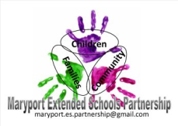
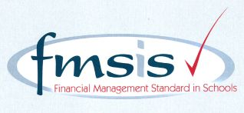
Big enough for opportunity
Small enough to care

CROSSCANONBY ST JOHN'S CofE PRIMARY SCHOOL

Mrs A Pitcher Telephone: 01900 812326
Executive Headteacher Fax: 01900 816420
Garborough Close e-mail: head@crosscanonby.cumbria.sch.uk
Crosby www.crosscanonby.cumbria.sch.uk

MARYPORT

Cumbria CA15 6RX

Dear Parents/Guardians,

For your information we have outlined below some of the topics that will be covered this term in Year 1. We have already made a good start to our studies and we feel sure that you will make every effort to assist and encourage your child as this term progresses.

ENGLISH:
- Harvest- The Little Red Hen
- Story sequencing
- Drama
- Stories with familiar settings

SPaG (Spelling, grammar and punctuation):
- Sentence formation
- Capital letters

SCIENCE:
- Physics – Seasons
- Biology- Life cycle of plants

MATHEMATICS:
- Place value
- Addition and subtraction
- Shape

HISTORY:
- The Great Fire of London

GEOGRAPHY:
- Our local area which includes:
  - Mapping skills
  - Recognising housing types
  - Recognising familiar places in their local area

ART and DESIGN AND TECHNOLOGY:
- Self Portraits
- Moving vehicles

RE:
- How do Christians show they are thankful during harvest?
- What are the messages of Christmas?

PE:
- Dance

COMPUTING:
- Internet Safety
- Grouping and sorting

MUSIC
- Hey you!- Finding rhythm and beat
- Rhythm In The Way We Walk- Action songs

